Pizza Sales SQL Queries

1. **KPI’s**
2. **Total Revenue:**

select SUM(total_price) as Total_Revenue from pizza_sales;

ANSWER = 817860.05083847

1. **Average Order Value**

select SUM(total_price) / COUNT(distinct order_id) as Avg_Order_Value from pizza_sales;

ANSWER = 38.3072623343546

1. **Total Pizzas Sold**

select SUM(quantity) as Total_Pizza_Sold from pizza_sales;

ANSWER = 49574

1. **Total Orders**

select COUNT(distinct order_id) as Total_Orders from pizza_sales;

ANSWER = 21350

1. **Average Pizzas Per Order**

select CAST(CAST(SUM(quantity) as decimal(10,2)) /

CAST(COUNT(distinct order_id) as decimal(10,2)) as decimal(10,2))

as Avg_Pizzas_Per_Order

from pizza_sales;

ANSWER = 2.32

1. **Daily Trend for Total Orders**

select DATENAME(DW, order_date) as order_day, COUNT(distinct order_id) as total_orders

from pizza_sales

group by DATENAME(DW, order_date);

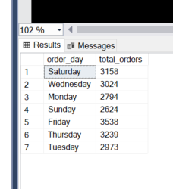

1. **Monthly Trend for Orders**

select DATENAME(MONTH, order_date) as Month_Name, COUNT(distinct order_id)

as total_orders

from pizza_sales

group by DATENAME(MONTH, order_date)

order by total_orders desc;

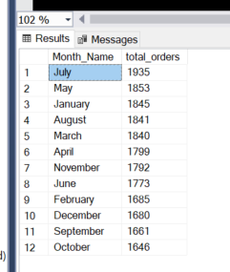

1. **% of Sales by Pizza Category**

select pizza_category, CAST(SUM(total_price) as decimal(10,2)) as total_revenue,

CAST(SUM(total_price) * 100 / (select SUM(total_price) from pizza_sales)

as decimal(10,2)) as PCT

from pizza_sales

group by pizza_category;

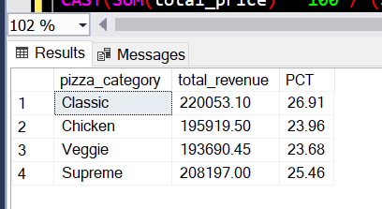

1. **% of Sales by Pizza Size**

select pizza_size, CAST(SUM(total_price) as decimal(10,2))

as total_revenue,

CAST(SUM(total_price) * 100 / (select SUM(total_price) from pizza_sales)

as decimal(10,2)) as PCT

from pizza_sales

group by pizza_size

order by pizza_size;

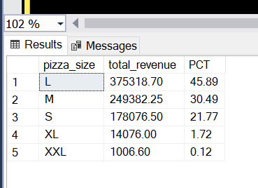

1. **Total Pizzas Sold by Pizza Category**

select pizza_category, SUM(quantity) as Total_Quantity_Sold

from pizza_sales

--where MONTH(order_date) = 3, (calculates total sold of each category depending on specific month)

group by pizza_category

order by Total_Quantity_Sold desc;

1. **Top 5 Pizzas by Revenue**

select top 5 pizza_name, SUM(total_price) as Total_Revenue

from pizza_sales

group by pizza_name

order by Total_Revenue desc;

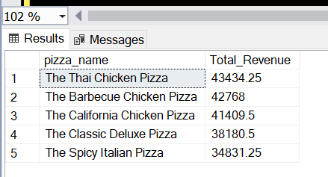

1. **Bottom 5 Pizzas by Revenue**

select top 5 pizza_name, SUM(total_price) as Total_Revenue

from pizza_sales

group by pizza_name

order by Total_Revenue asc;

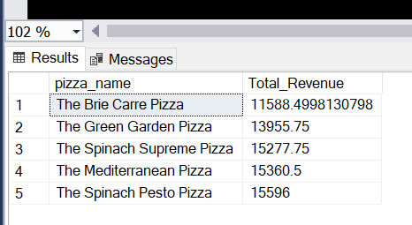

1. **Top 5 Pizzas by Quantity**

select top 5 pizza_name, SUM(quantity) as Total_Quantity

from pizza_sales

group by pizza_name

order by Total_Quantity desc;

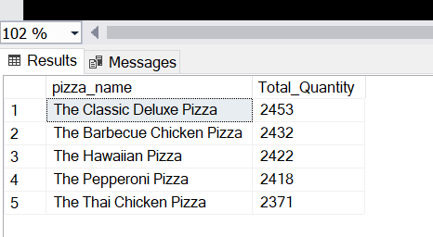

1. **Bottom 5 Pizzas by Quantity**

select top 5 pizza_name, SUM(quantity) as Total_Quantity

from pizza_sales

group by pizza_name

order by Total_Quantity asc;

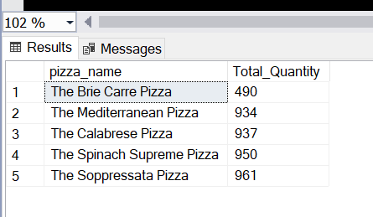

1. **Top 5 Pizzas by Total Orders**

select top 5 pizza_name, COUNT(distinct order_id) as Total_Orders

from pizza_sales

group by pizza_name

order by Total_Orders desc;

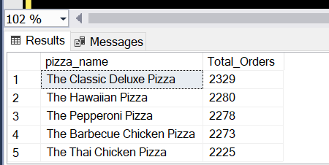

1. **Bottom 5 Pizzas by Total Orders**

select top 5 pizza_name, COUNT(distinct order_id) as Total_Orders

from pizza_sales

group by pizza_name

order by Total_Orders asc;

